Welcome to year 3! Here is a little bit of information about what school will be like when you come back in September.

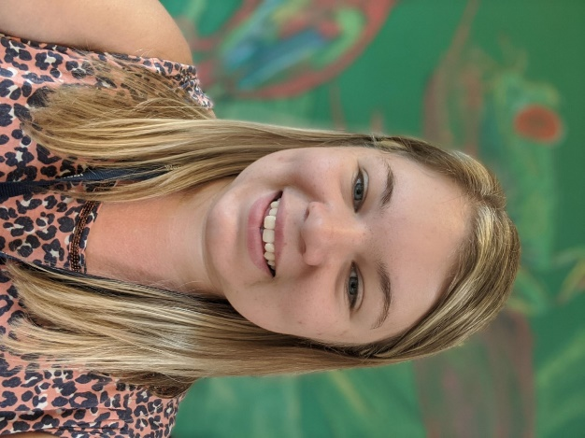
Hello! I am Mrs Bracher. I am going to be your class teacher and I will be with you each day of the week.

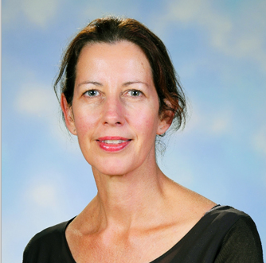
Hello! I am Mrs Allcorn. I am going to be your teaching assistant and I will be in school each day but I will be working in year 3 and year 4.

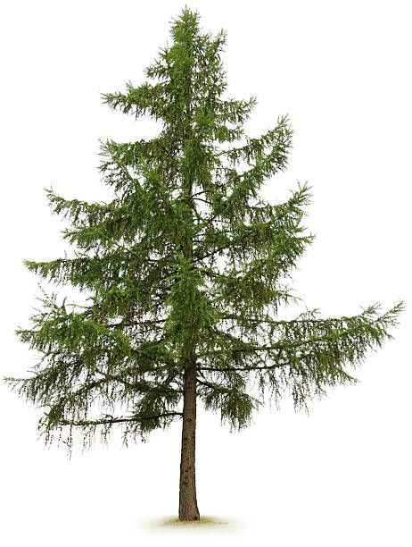

The name of your class is
Larch Class

Coming back to school
For most of you, it will have been a long time since you have been in school at Western Road. When we come back to school, some things will be different but lots of things will be the same as when you left in March.

What will be the same?
- We will still use the same equipment such as pens, pencils, rulers and art equipment.
- We will still do our work in books which will be marked by Mrs Bracher when we have finished.
- We can still borrow books from the library and read books from our class book area.
- We will still go outside during break and lunchtime.
- We will still take part in any sports clubs after school and music lessons such as guitar or piano.
- You are still expected to wear your normal school uniform and PE kit for PE lessons.

What will be different?
- You will have a new teacher and teaching assistant.
- You will have a new classroom. We are going to be in the room that used to be year 5!
- We might have slightly different times to come to school as well as different times for break and lunch time.
- There will not be any assemblies (other than class assemblies) or Miss Doone’s Choir club for the time being.
- Some of the equipment that you use in school might be labelled for you and kept in your own plastic wallet so that only you can use it.
- You will be expected to wash your hands a lot more in school and keep your distance from others as much as you can.

How will year 3 be different from year 4?

- One big difference is that your classroom will be upstairs now!
- We will have different topics in year 3.
- We will be doing the daily mile each day and trying to run a little bit further each day.
- In year 3 we will have two different children to be our school council members.
- We will use the ‘smiley face’ behaviour system to show our merits for the day.

Have a really lovely summer holidays and we look forward to seeing you back in school very soon!
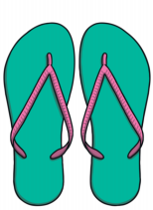
If you have any other questions please ask an adult to email Mrs Wooler who can pass on messages to me.
Enjoy your summer
See you in September

