Communication, Language and Literacy
- Speaking and Listening – sharing their thoughts, interests and opinions.
- Listen to stories and anticipate events.
- Describe settings, events and principal characters.
- Demonstrate an understanding when talking to others about what they have read.
- Use key features of narrative in their own writing.
- Write simple sentences that can be read by themselves and others.
- Learn letter names.
- Read sentences consistent with phonics knowledge.
Personal, Social & Emotional Development
- Talk about the behaviour and actions of various characters in stories.
- Explain the reason for rules.
- Choose resources independently for their chosen activity.
- Express their feelings and consider the feelings of others.
- Talk about things they enjoy and are good at and about the things they do not find easy.
- Challenge character and gender stereotypes.

Mathematics
- Count reliably objects, actions and sounds.
- Say what is 1 more/less than a given number.
- Compare quantities up to 10 in different ways using language ‘more than’ ‘less than’ and ‘the same’
- Add/subtract single digit numbers and count on/back to find the answer.
- Use knowledge of number bonds to solve puzzles and problems.
- Explore numbers to 20.

PD

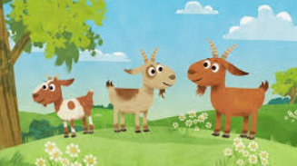
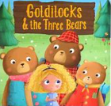
Once upon a time…
Term 5
Understanding the World
- Talk about members of their immediate family and community.
- Use information texts to find out about castles, the monarchy and life long ago.
- Explore why some things occur and talk about changes – linked to cooking
- Know the difference between past and present and some reasons why other people’s lives were different in the past.
- Explore the natural world around them, making observations about plants, animals and the seasons.

Creative Development
- Sing a range of songs exploring pitch, volume, tempo.
- Listen attentively, move and talk about music.
- Represent their own ideas, thoughts and feelings.
- Study ‘Castle and Sun’ by Paul Klee
- Experiment with design and function.
- Create our own knight shields.
- Return to previous work, and refine their ideas.
- Reflect on their work, talk about how they can make improvements.

Physical Development
- Show control and co-ordination with large and small movements.
- Effectively negotiate space and obstacles safely.
- Move confidently in a range of ways.
- Begin to write on lines and control their letter size.
- Handle tools and equipment effectively.
- Develop their motor control so they can use a range of tools competently, safely and confidently e.g. knife and fork, paintbrush and scissors.

