Western Road Community
Primary School

Welcome to Year 5, Elder Class

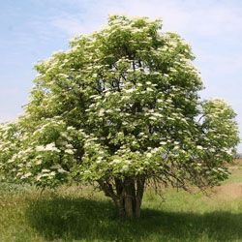

We are all very excited to meet you properly in September, getting to know you better and becoming a super year 5 class!

Your adults will be:
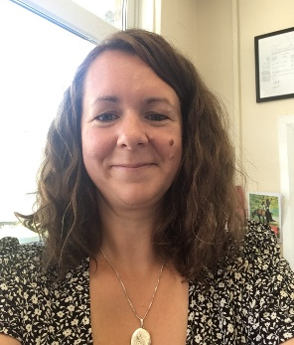
Mrs Bedford (Class Teacher)
I will be teaching you on Monday and Tuesday.
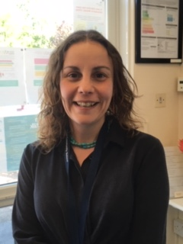
Mrs Hamilton (Class Teacher)
I will be teaching you on Wednesday, Thursday and Friday.

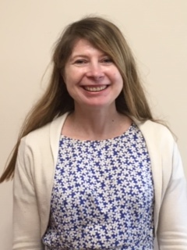
Mrs Hills (Teaching Assistant)
I will be supporting you in class every day.

What will school be like in September? Where is our classroom?

We will be helping you to settle back into school life and finding lots of opportunities to explore and talk about transition from Year 4 to Year 5.

Our class is going to be the old year 3 classroom (the room you were in with Miss Hoare.) The classroom is big and bright, and the walls will be proudly filled with your wonderful work as you complete it.
Every morning, you will place your things on your peg, then come into the room calmly and ready to learn. You will be welcomed with some mindful music, where you will take your seat and complete an early morning learning task; maths, grammar, handwriting or reading activity.

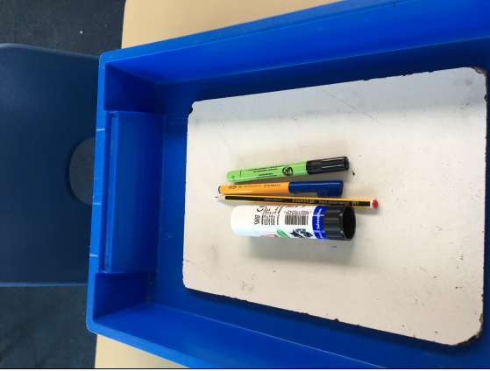
To keep you safe: You will be facing forwards in the classroom. You will have a drawer and equipment just for you. It will be your responsibility to look after your own equipment. We will be spending lots of time together to make sure we are safe. This means that for a short while, you will be spending your lunch and break times together rather than with lots of other classes. We will need to make sure we are regularly washing our hands throughout the day.

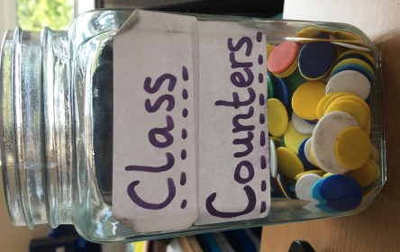
Our learning: You will still work in books and we will mark these and award you with merits when you have made an excellent effort! You will get merits for making good learning and behaviour choices, and being polite. We will continue to earn class counters to go towards exciting class rewards, like extra break time and class parties.

We will have a selection of excellent books for you to read both alone and with an adult in school. We all love reading, and hope to start a borrowing box where we can share books that we recommend reading with others.

Every day, we will do the daily mile, some indoor exercise routines or yoga to get us moving, keeping us healthy and getting our minds ready to learn.

We have some very exciting learning topics planned for this year. We will begin with a focus on Roald Dahl’s books, Boy and the BFG. We will be using these as a stimulus for our own poetry, autobiographical writing and oral storytelling. These will also inspire our coverage of other areas of the curriculum. In Science we will be creating dream potions to study chemical reactions and changes in materials. In Geography, we will be focusing on Roald Dahl’s birth place; Norway. in Art and D.T we will create our own dream catchers and explore various painting techniques. We will be continuing with our Mastery of Maths approach using some new resources. We will also be continuing to encourage you to use TT Rockstars to practise your times tables.
are sure we are going to have a fantastic time!

Have a fabulous summer: we look forward to seeing you in September!

