 | 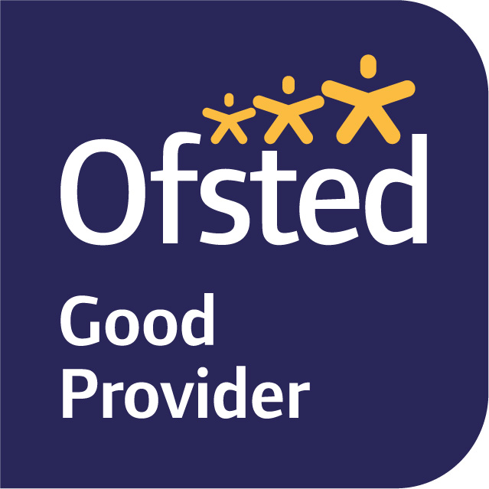

November 2024

Dear Parents and Carers,

Welcome to Term 2 - we hope that you had a relaxing half term. Our topic for term 2 is Extreme Weather. This unit explores weather, particularly looking at the extremes such as floods, global warming and storms. During this topic, we will learn about the impact of the Lewes flood, as well as other storms such as hurricanes in Florida.

In English, we are starting this term by looking at the book ‘Flood’ by Alvaro Villa. This is a textless book about a family who encounter a flood, but end up coming back afterwards and repairing their home. We will use this book to describe the house during the flood as well as writing safety advice for how to weather proof your house. We will also be writing instructions to survive a natural disaster!

In maths, we are starting this term continuing our unit of ‘addition and subtraction.’ The class have been working hard to learn the column method for both addition and subtraction. We are now looking at other methods such as using rounding and using the inverse operation to check our answer.

Our science this term is all about electricity. This is an exciting unit where we will create our own circuits, explore conductors and insulators and learn about electrical safety.
In PSHE this term, we will focus on Citizenship. We will learn what human rights are and why they are important; understand how reusing items benefits the environment; understand the range of groups that exist in the wider community; and how community groups can focus on different areas of interest.
PE this term is on a Tuesday and Friday, where we will focus on ball skills and fundamental skills, which include balancing, running, jumping, hopping and skipping.
In Art, we will be studying various inspirational artists (such as Olafur Eliasson, Frank Auerbach, Joseph Turner, Paul Nash, Peter Doig, David Hockney, Eric Ravillious to name a few) as to how they use different techniques to illustrate weather in their art for example rain, wind, snow and sun. We will be building on the skills we learnt in Year 3 using the mediums of watercolour, collage, chalk pastels and pen and ink, whilst continuing to analyse the 7 elements of Art – line, shape, colour, form, space, texture & value.

In RE, we will be looking at Hinduism and asking ‘what do Hindus believe God is like?’

In French, we will continue to build on the knowledge we learnt in Year Three by looking at animals, numbers, colours, instructions and basic noun phrases.

We are lucky enough to continue with our brass instrument lessons led by Brass Sparks, where we focus on rhythm, pulse and playing as a band.

Homework this term is set as a homework grid. This will be set at the beginning of the term and each child will bring home a homework pack at the end of the first week back. We will also upload the documents onto Seesaw. We would like each child to complete one piece of work each week and either bring it in to show us or upload it to Seesaw. The homework grid runs alongside weekly Mymaths homework and daily reading as well as practising spellings and times tables.

If you have any queries, please do not hesitate to see us.

Yours sincerely,

Ms Margie Krijnauw and Mrs Alice Bracher
Year Four Class Teachers

