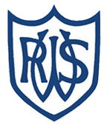 | 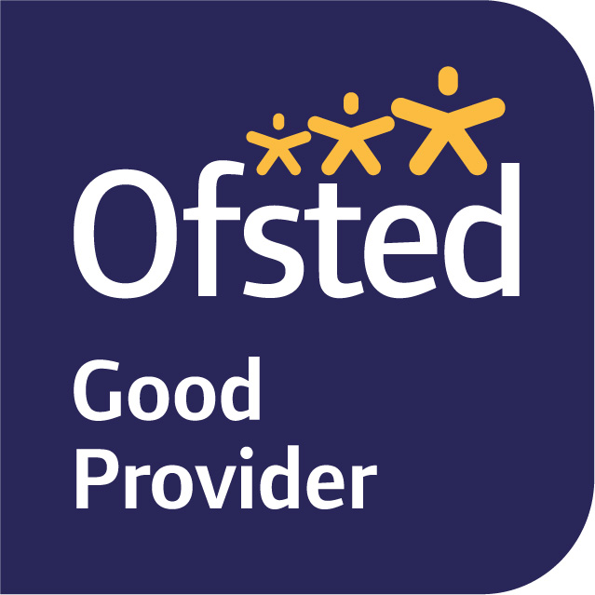

February 2024

Dear Parents and Carers,
Welcome back! I hope you all had a wonderful, relaxing half term and are looking forward to Term 4. Our topic for this term is The Great Fire of London which I know a lot of the children have been very excited about.
In English, we will become journalists and research what happened during the great fire so that we can write our own newspaper articles. We will also be looking at Samuel Pepys’ diary and creating our own entries. Towards the end of term we will be writing our own fire poems and using some of the artwork we create to decorate these.
In Maths, we are moving onto multiplication and division. Look out for Timetables Rockstar login details which will be given out with homework. We will start this by looking at equal groups which will then turn into repeated addition, which will then support us with some multiplication problems. Once we are confident with this we will start to look at it in reverse to learn division.
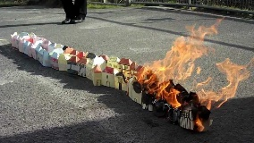
In Science, we are studying materials and their properties and have some experiments lined up to help us increase our exploration and data gathering skills. In art, we will be creating our own houses similar to the houses that were destroyed in the fire and are hoping to be able to set these on fire so that we are able to see just how quick and easy it was for the fire to spread when the houses were all so close together! We will be having a visit from Lewes Fire Brigade who will talk to us about fire safety and how firefighting has changed over time. In geography, we are going to be looking at maps of London and creating our own scrap books of famous landmarks and in music we will be getting musical instruments out in order to create our own versions of ‘London’s Burning’.
Our PE session are Monday and Thursday this term, so please could your child wear their PE kit to school on these days. One of our sessions is ball skills and the other we will be looking in to using these skills for some games.
If you have any queries, please do not hesitate to speak to me.
King regards,
Miss Blackwell
Year Two Class Teacher

