The theme for Safer Internet Day this year was…

‘**All fun and games? Exploring and respect and relationships online.**



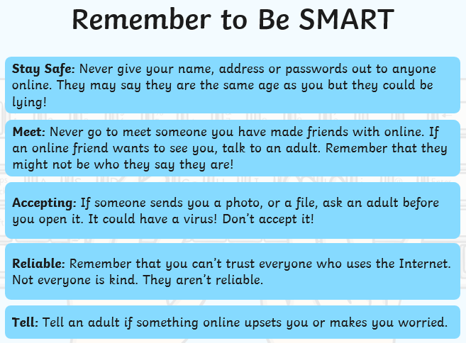

**What did we do?**

School Council thought it was important to raise the awareness of E-Safety. They led a KS1 and KS2 assembly on Tuesday 8th February. They spoke about what internet safety is, how to stay safe online and what to do if you feel unhappy or worried about something you see or hear online.

**All classes…**

Discussed what e-safety is, how you can keep yourself safe online and who you can talk to if you are concerned about something you see or hear online.

Classes also discussed the importance of age-restrictions of resources online.

**Online Safety**

**Safer Internet Day: 8th February 2022**

**What is Safer Internet Day?**

Safer Internet Day is a national day which aims to educate and inform children and their families about how we can stay safe online.