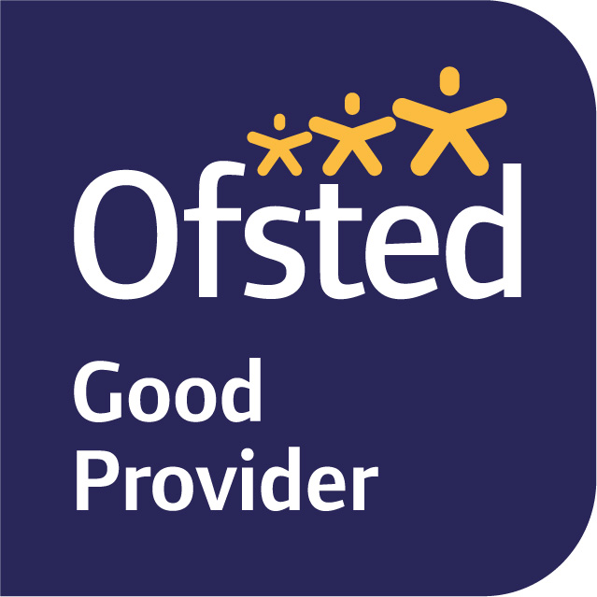

Dear Parents and Carers, November 2023
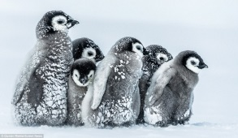
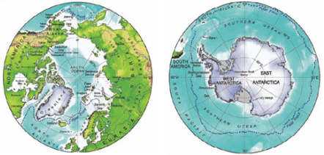
Term Two has arrived and our topic is ICE! This term we will be exploring the polar regions of the world, finding out about what these unique environments are like and how animals and plants survive there. Our enquiry question is ‘What do we know about the world and how does it shape the way we live?’
In English, we will be reading ‘Emperor’s egg’ and researching all about emperor penguins in order to write our own versions of a non-fiction text in a story style. As well as this we will also be writing Autumn poems and using the books ‘Dear Greenpeace’ and ‘Lost and Found’ to write instructions on how to look after an arctic animal.
In Maths, we will continue to focus on place value, addition and subtraction. We will be using column addition and subtraction to find and explain answers. The children will also be interacting with the concept of money, understanding which coins to use for different amounts, finding change and using addition and subtraction in money problem solving activities.
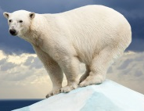
In Science, we are studying living things and their habitats, looking at how living things are adapted to their environment, such as polar bears in the Arctic. In PSHE we will be discussing responsibility and consequences linking this in with discussions about climate change. In RE the children will be thinking about Christianity and the Christmas story in preparation for the Nativity later in the term. In History we are learning about Ernest Shackleton and his polar expeditions.
We will have yoga on Tuesdays and dance on Thursdays. Please wear PE kit to school on these days.
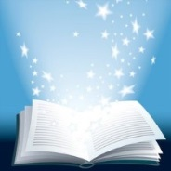
Your child will be encouraged to change their coloured book on the day they read with a teacher during guided reading, but children are free to change books whenever they need a new one independently. We will be starting to use the library every other week as well. These books can be enjoyed independently or together.
If you have any queries, please do not hesitate to speak to me.

Yours sincerely,

Miss Blackwell
Year Two Class Teacher

