How much did we raise?

We raised £294.50 thanks to all the children, parents and staff!The money will be used to support a range of needs including physical and mental health of young children.

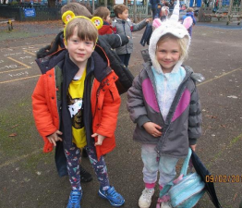

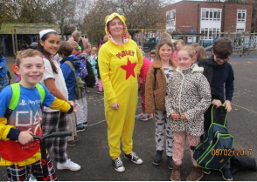

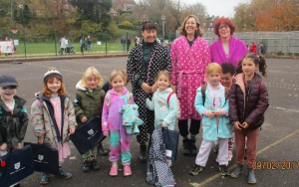



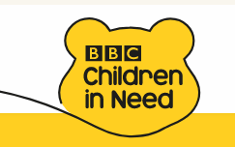

How did we support Children in Need?

The children at Western Road decided to…

* Wear yellow/ spots or PJ day!
* Hold a cake sale
* Joined Dr Ranj for mindfulness workshop
* Took part in Joe Wickes workout

What was the role of School Council?

The School Council involved the school in deciding how we would like to support Children in Need through a democratic voting system.

Why do we think it is important?

The children at Western Road Community Primary School thought it was important to support disadvantaged children by raising awareness about the charity and money to help others.

What is ‘Children in Need’?

Children in Need is the official charity of the BBC (British Broadcasting Corporation). It raises money for disadvantaged children and young people in the UK. The end goal for Children in Need is to make sure that every child has a safe, happy and secure childhood.

**Children in Need**

**19th November 2021**