Language of a Historian
London | The capital city of England and the United Kingdom.
Flammable | When something burns easily.
Tudor house | Houses that were built between 1485 – 1603. They had a very distinctive black-and-white style appearance and were usually made of wood, wattle and daub.
Ember | a small piece of glowing wood or coal in a dying fire.
Diary | a daily personal record someone writes about the events of their day
Pudding lane | A street in London where Thomas Farriner’s bakery was.
Fire hook | a stout pole having a hooked metal head and used especially in firefighting for tearing down walls or ceilings.
Monument | A structure to help people remember a person or event.
Key people
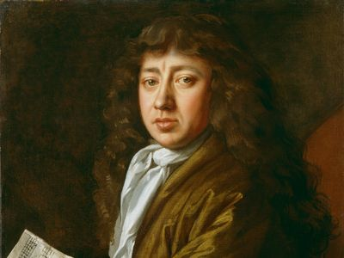  Samuel Pepys | - He wrote a very important diary.  - In his diary he described two of the most important events in English history: The Plague in 1665 and the Great Fire of London in 1666.
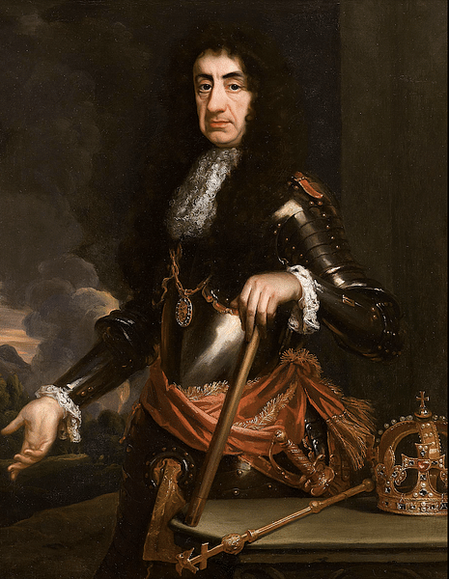  King Charles 11 | Charles II was the King of England in 1666.After the fire, he made a decree that houses must be built further apart and built from stone not timber.
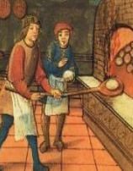  Thomas Farriner | Thomas Farriner was the King’s baker. He owned a bakery on Pudding Lane in 1666. This is where the fire started.
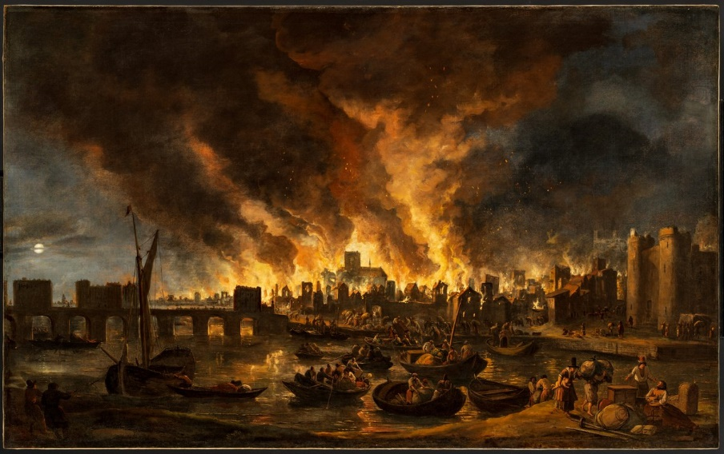
How did The Great Fire of London change London and the way we live now?

Timeline
Sunday 2nd September 1666  A fire starts in Thomas Farriner’s bakery on Pudding Lane. As news of the fire spreads, people run to escape its path. | Monday 3rd September 1666  Fire-fighters try to tackle the fire but it spreads quickly. People carry their possessions to safety using horse and cart or boats on the River Thames. | Tuesday 4th September 1666  Houses are pulled down in an attempt to stop the fire spreading. St. Paul’s Cathedral is destroyed. | Wednesday 5th September 1666  The fire starts to burn more slowly as the wind dies down. | Thursday 6th September 1666  The fire is finally under control and put out. People are left homeless.
Overview of topic
This term we are becoming historians! We will be researching what happened during The Great Fire London in 1666 and thinking about the impact it has made to our lives today. We will be travelling back in time to understand what life was like at the time it happened and compare it to our lives now.

