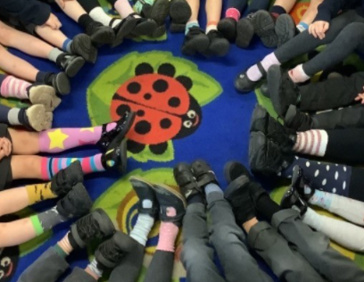

**What did we do?**

School Council thought it was important to raise the awareness of Anti-Bullying. They led a whole school assembly on Monday 15th November talking about what bullying is, who you can talk to if you or someone you know is having difficulties.

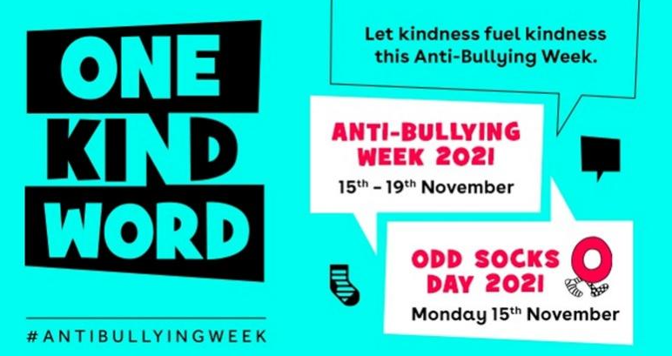

**What is Anti-Bullying Week?**

Anti-Bullying Week 2021 was coordinated In England and Wales by the Anti-Bullying Alliance. It took place from 15 to 19 November 2021 and had the theme One Kind Word. The week began with Odd Socks Day which was supported by CBBC and CBeebies star Andy Day and his band Andy and the Odd Socks.

**What is ‘Odd Socks Day’ all about?**

The School Council were keen for us to signify the start of Anti-Bullying Week by taking part in national ‘Odd Socks Day’. This is to remind us that we are all different and unique and lets be kind to each other and respect each others individuality. We had circle time and PSHE lessons in our classes to explore this in detail.

**All classes…**

Discussed what bullying is, who you can talk to about bullying and active steps you can take to combat bullying such as reporting offensive users online.

All classes discussed the Zones of Regulation and have worry boxes in their classes.

**Anti-Bullying Week: One Kind Word**

**15th-19th November 2021**