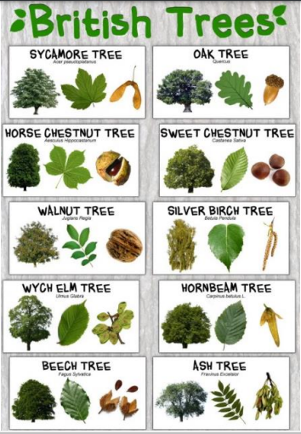
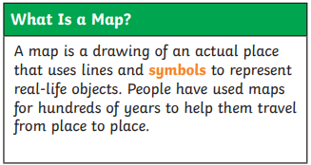
How does a plant grow? Why is it so important to look after plants?
IN TO THE WOODS

Language of a Scientist
Wild plants | Plants that grow spontaneously in an area of nature and do not rely on human input.
Deciduous | A tree that loses its leaves in the autumn every year.
Evergreen | A tree that has green leaves all the year round.
Plant | Plants are living things that grow from the soil and turn light from the sun into food. Plants can be big or small, from giant trees to tiny patches of moss.
Bulb | A bulb is the part of some plants, mostly under the dirt, that stores food while the plant is resting from growing (a storage organ).  Some well-known bulbs people grow to use as food are onions and garlic. Some bulbs grown for the decorative flowers are the lily, tulip, and some irises.
Seed | A seed is the part of a seed plant which can grow into a new plant.
Stem | The main part of a plant that grows up from the ground and supports the branches, leaves, flowers, or fruits that may grow from it.
Germination | Germination is the growth of a seed into a young plant or a seedling.
Reproduction | the process by which living things create young or offspring.
