The votes indicated that the children at Western Road School decided they wanted to support Raystede so we contacted them to find out how we could help.



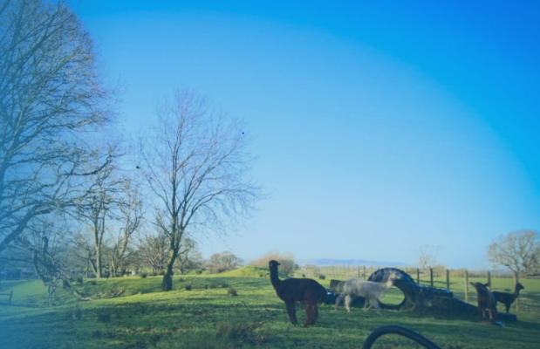



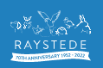

We wrote a letter to the school community asking for animal blankets, toys and food.

The School Council analysed the results across the school to find out the overall winning charity.

The children at Western Road School wanted to support a charity in the lead up to Christmas.

School Council presented a range of charities to their classes and facilitated a class vote to decide which was the most popular charity.

Our charity support story…

We will be inviting Raystede to come in to school in the New Year to talk about how we helped the centre.

Donations were gathered at school and presented to Raystede in the lead up to Christmas.

Raystede Centre for Animal Welfare